THE INTERNATIONAL UNIVERSITY (IU)
VIETNAM NATIONAL UNIVERSITY - HCMC
assignment – ANSWER
SUBJECT: PHYSICS 4
Question 1 (25 marks)
a/ 3.80 cm or 14.2 cm.
b/ -0,268 or -3.74
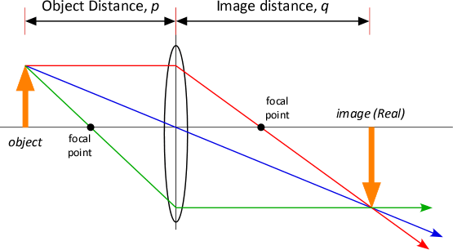
c/

Question 2 (25 marks)
a/ 0.60
b/ 0.20
Question 3 (25 marks)
a/ 1.1×10⁷ m⁻¹.
b/ 1.21×10⁻⁷ m, 1.02×10⁻⁷ m.
Question 4 (25 marks)
a/ 0.091
b/ 0.409
c/ The particle is nearer to the middle than the edge.
d/ P = 0.5: The particle in 0-L/2 with half of probability.

The end

